**Major Project**

**2nd Review Report**

**On**

**Customer Satisfaction Based On Their Queries For Business Development**

**Project Guide: Mrs Uma.M**

**1201310056 – Mohit Ratnesh**

**1201310057 – Sourabh Agarwal**

ER-Diagram

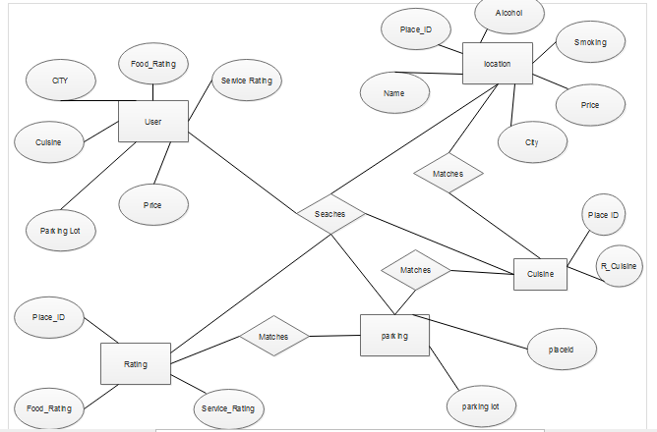

Relational Model Diagram

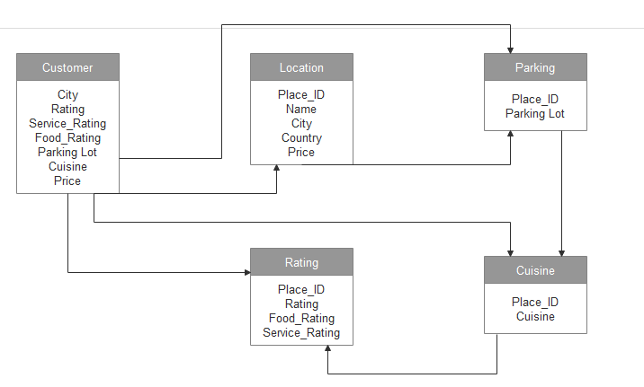

Technologies Used

* Weka 3.8
* NetBeansID 8.0.2
* Oracle 10 G Express Edition
* MS Excel
* HTML,CSS And JSP
* GlassFish Server

Application Coding

<%@ page import="java.lang.*" %>

<%@ page import="java.sql.*" %>

<%@ page import="java.util.*" %>

<% Class.forName("oracle.jdbc.driver.OracleDriver"); %>

<%

Connection connection = DriverManager.getConnection("jdbc:oracle:thin:@localhost:1521:xe","system", "sourabh007");

String i=request.getParameter("frat");

String j=request.getParameter("srat");

Statement statement = connection.createStatement() ;

if(i.equals("1") && j.equals("2"))

{

ResultSet rs1 =

statement.executeQuery("select * from RESTAURANT where RATING = '2'") ;

%>

<TABLE BORDER="1">

<TR>

<TH>Name</TH>

<TH>Place</TH>

</TR>

<% while(rs1.next()){ %>

<TR>

<TD> <%= rs1.getString(9) %></td>

<TD> <%= rs1.getString(11) %></TD>

</TR>

<% } %>

</TABLE><% } %>

<% if(i.equals("2") && j.equals("2"))

{

ResultSet rs2 =

statement.executeQuery("select * from RESTAURANT where RATING = '2'") ;

%>

<TABLE BORDER="1">

<TR>

<TH>Name</TH>

<TH>Place</TH>

</TR>

<% while(rs2.next()){ %>

<TR>

<TD> <%= rs2.getString(9) %></td>

<TD> <%= rs2.getString(11) %></TD>

</TR>

<% } %>

</TABLE><% } %>

<% if(i.equals("0") && j.equals("1"))

{

ResultSet rs3 =

statement.executeQuery("select * from RESTAURANT where RATING = '1'") ;

%>

<TABLE BORDER="1">

<TR>

<TH>Name</TH>

<TH>Place</TH>

</TR>

<% while(rs3.next()){ %>

<TR>

<TD> <%= rs3.getString(9) %></td>

<TD> <%= rs3.getString(11) %></TD>

</TR>

<% } %>

</TABLE><% } %>

<% if(i.equals("1") && j.equals("1"))

{

ResultSet rs4 =

statement.executeQuery("select * from RESTAURANT where RATING = '1'") ;

%>

<TABLE BORDER="1">

<TR>

<TH>Name</TH>

<TH>Place</TH>

</TR>

<% while(rs4.next()){ %>

<TR>

<TD> <%= rs4.getString(9) %></td>

<TD> <%= rs4.getString(11) %></TD>

</TR>

<% } %>

</TABLE><% } %>

<% if(i.equals("2") && j.equals("1"))

{

ResultSet rs5 =

statement.executeQuery("select * from RESTAURANT where RATING = '1'") ;

%>

<TABLE BORDER="1">

<TR>

<TH>Name</TH>

<TH>Place</TH>

</TR>

<% while(rs5.next()){ %>

<TR>

<TD> <%= rs5.getString(9) %></td>

<TD> <%= rs5.getString(11) %></TD>

</TR>

<% } %>

</TABLE><% } %>

<% if(i.equals("1") && j.equals("0"))

{

ResultSet rs6 =

statement.executeQuery("select * from RESTAURANT where RATING = '1'") ;

%>

<TABLE BORDER="1">

<TR>

<TH>Name</TH>

<TH>Place</TH>

</TR>

<% while(rs6.next()){ %>

<TR>

<TD> <%= rs6.getString(9) %></td>

<TD> <%= rs6.getString(11) %></TD>

</TR>

<% } %>

</TABLE><% } %>

<% if(i.equals("2") && j.equals("0"))

{

ResultSet rs7 =

statement.executeQuery("select * from RESTAURANT where RATING = '1'") ;

%>

<TABLE BORDER="1">

<TR>

<TH>Name</TH>

<TH>Place</TH>

</TR>

<% while(rs7.next()){ %>

<TR>

<TD> <%= rs7.getString(9) %></td>

<TD> <%= rs7.getString(11) %></TD>

</TR>

<% } %>

</TABLE><% } %>

<% if(i.equals("0") && j.equals("0"))

{

ResultSet rs8 =

statement.executeQuery("select * from RESTAURANT where RATING = '0'") ;

%>

<TABLE BORDER="1">

<TR>

<TH>Name</TH>

<TH>Place</TH>

</TR>

<% while(rs8.next()){ %>

<TR>

<TD> <%= rs8.getString(9) %></td>

<TD> <%= rs8.getString(11) %></TD>

</TR>

<% } %>

</TABLE><% } %>

<% if(i.equals("0") && j.equals("2"))

{

ResultSet rs9 =

statement.executeQuery("select * from RESTAURANT where RATING = '1'") ;

%>

<TABLE BORDER="1">

<TR>

<TH>Name</TH>

<TH>Place</TH>

</TR>

<% while(rs9.next()){ %>

<TR>

<TD> <%= rs9.getString(9) %></td>

<TD> <%= rs9.getString(11) %></TD>

</TR>

<% } %>

</TABLE><% } %>

Application Coding Screenshot

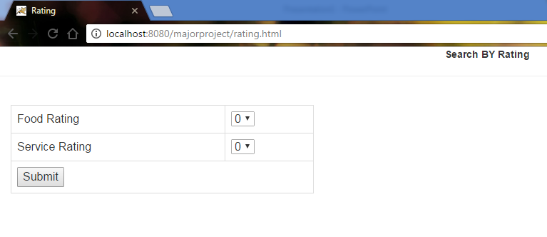

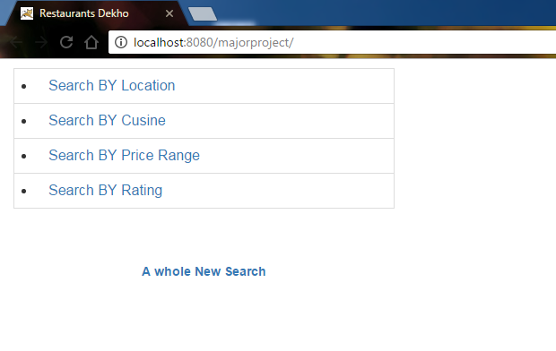

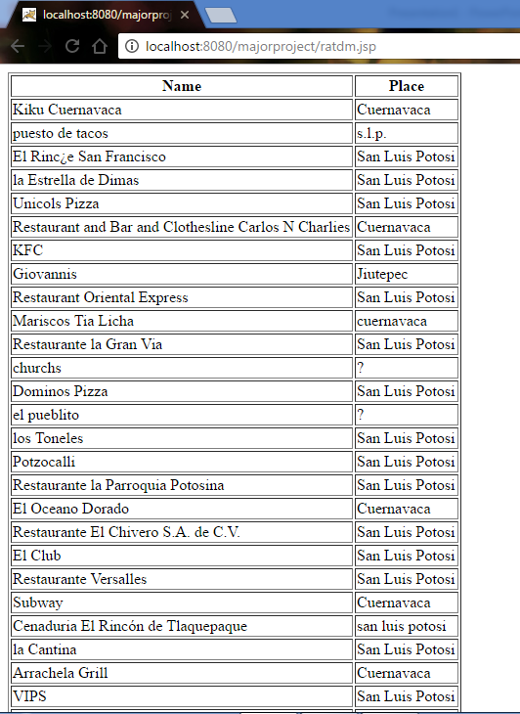

Application Middle Ware Screenshot

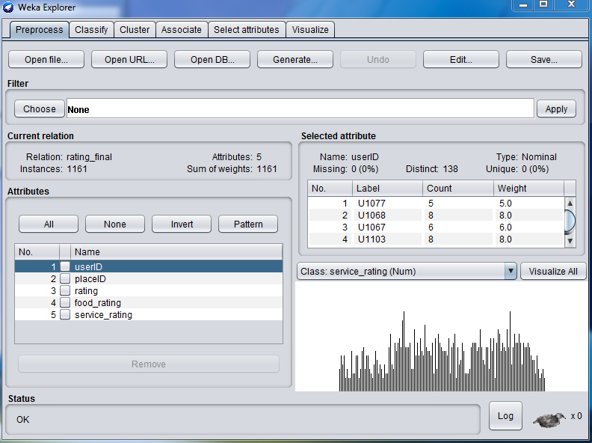

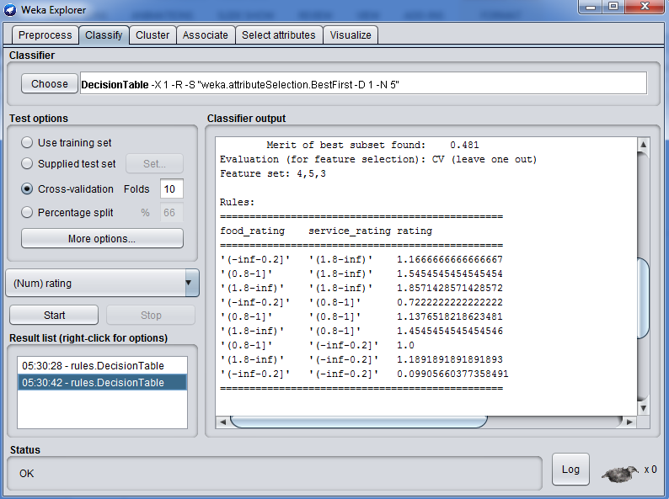

Unit Testing

Test Plans :-

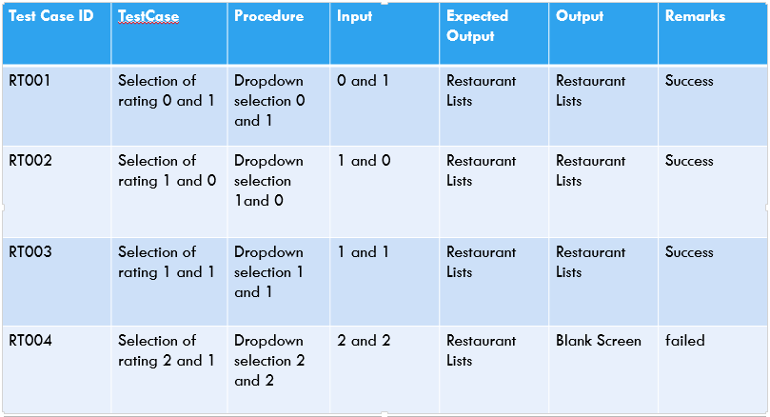

Equivalence Partitioning :-

